EMCH 368 – Laboratory 5

Mechatronics Laboratory 5

Jacob Vaught
09/26/2022

Department of Mechanical Engineering
University of South Carolina
Columbia, SC 29201

Abstract
This lab was designed to teach students how to use topics learned in class for practical applications. The goal is to create a circuit that will send power to 6 LEDs in order until 1 minute of time has passed. After all LEDs are on, a buzzer shall buzz every 3 seconds in perpetuity until a button has been pressed which resets the circuit, and thus the cycle continues again.

Introduction
When approaching the project, there are multiple avenues which lead to a final solution, however, each has their own drawbacks, and must be used in different scenarios.
The first avenue explored was a simple circuit with 6 LEDs connected to the digital Arduino pins, and the button and buzzer are connected to digital pins. The circuit used in all versions of the project are very similar with only minimal changes. However, the code changes dramatically between each version. The 3 possibilities explored to optimize the project included code optimization, interrupt functions, and using the reset pin on the Arduino

Optimizing Code
When first completing the project, a barbaric system was used, with hardcoded variables and other such atrocities. The code is referenced in Figure 1.
Figure 1 describes the hard-coded version of code
unsigned long time = 0UL;
int buttonPress;
boolean ringAlarm = true, run = false, buttonPressed = false;
void setup() {
pinMode(8, OUTPUT);
pinMode(9, OUTPUT);
pinMode(10, OUTPUT);
pinMode(11, OUTPUT);
pinMode(12, OUTPUT);
pinMode(13, OUTPUT);
pinMode(6, INPUT);
pinMode(7, OUTPUT);
}
void loop() {
buttonPress = digitalRead(6);
if (buttonPress == HIGH) {
buttonPressed = true;
digitalWrite(7, LOW);
digitalWrite(8, LOW);
digitalWrite(9, LOW);
digitalWrite(10, LOW);
digitalWrite(11, LOW);
digitalWrite(12, LOW);
digitalWrite(13, LOW);
delay(10000);
digitalWrite(13, HIGH);
delay(10000);
digitalWrite(12, HIGH);
delay(10000);
digitalWrite(11, HIGH);
delay(10000);
digitalWrite(10, HIGH);
delay(10000);
digitalWrite(9, HIGH);
delay(10000);
digitalWrite(8, HIGH);
ringAlarm = true; //set ringAlarm boolean true (ring alarm)
} else if (ringAlarm && buttonPressed) { //if timer has finished becuase ringAlarm is true and button has been pressed, indicating at least 1 cycle has run
digitalWrite(7, HIGH); //turn buzzer on
time = millis(); //set time to current time, so that it is known when the alarm started.
ringAlarm = false; //set Ringalarm to false, so the alarm can turn off
} else if (!ringAlarm && buttonPressed) { //if alarm has run once and is ready to be truned off and button has been pressed, indicating at least 1 cycle has run
if (millis() - time > 3000UL && run) { //if current Time-the Time when alarm was turned off is larger than 3 seconds->
//AND runPart boolean for letting us know when to turn alarm back on is true
ringAlarm = true; //turn alarm on
run = false; //dont run this part again until other section is done
} else if (millis() - time > 300UL && !run) { //if current Time-the Time when alarm was turned on is larger than 0.3 seconds->
//AND runPart boolean for letting us know when to turn alarm back on is true
digitalWrite(7, LOW); //turn buzzer off
time = millis(); //set previoustime to time when alarm turns off
run = true; // tell arduino to get ready to turn buzzer on after 3 seconds
}
}
}

A more optimized version of code can be found in Figure 2, and has a parameterized codebase.
//LEDs are 8-13; Button is 5; buzzer is 7
unsigned long startTime = 0UL, alarmStartTime = 0UL, buzzerTimetoPlay = 100UL, timeBetweenBuzzer = 3000UL;
const int amountOfTime = 10000, firstLED = 8, numberOfLEDs = 6, buzzer = 7, button = 6;
int led = 0;
boolean ringAlarm = false, startLEDs = false, alarmRang = false;

void setup() {
for (int x = firstLED; x < firstLED + numberOfLEDs; x++) { pinMode(x, OUTPUT); }
pinMode(button, INPUT); //initialises button pin
pinMode(buzzer, OUTPUT); //initialises buzzer pin
} //end of setup method

void loop() {
if (digitalRead(button) == HIGH) {
led = 0;
for (int x = firstLED; x < firstLED + numberOfLEDs; x++) { digitalWrite(x, LOW); } //end of for loop
digitalWrite(buzzer, LOW);
startLEDs = true;
startTime = millis();
} else if (startLEDs) {
if (millis() - startTime >= amountOfTime) {
digitalWrite(firstLED + led, HIGH);
led++;
startTime = millis();
} else if (led >= numberOfLEDs) {
startLEDs = false;
ringAlarm = true;
}
} else if (ringAlarm) {
if (!alarmRang) {
alarmStartTime = millis();
digitalWrite(buzzer, HIGH);
delay(buzzerTimetoPlay);
digitalWrite(buzzer, LOW);
alarmRang = true;
} else if (alarmRang && millis() - alarmStartTime >= timeBetweenBuzzer) {
alarmRang = false;
}
}
delay(15);
}

Figure 2 shows the 2nd version of code, which is more optimized.

Interrupt Function
After reviewing Arduino documentation, it was determined that Arduinos support Interrupt functions. This is a brilliant way to reduce code length by removing a lot of control statements. The code is referenced in Figure 3 below.
Figure 3 references the Interrupt function used for a more optimized version of the code. This results in a ~30 line program
const int firstLED = 8, numberOfLEDs = 6, buzzer = 7, button = 2;
boolean run = false, LEDs = false;
void setup() {
for (int x = firstLED; x < firstLED + numberOfLEDs; x++) {
pinMode(x, OUTPUT);
}
attachInterrupt(digitalPinToInterrupt(button), button_ISR, RISING);
pinMode(buzzer, OUTPUT);
}
void loop() {
if (run) {
if (LEDs) {
for (int x = firstLED; x < firstLED + numberOfLEDs; x++) {
digitalWrite(x, LOW);
}
for (int x = firstLED; x < firstLED + numberOfLEDs; x++) {
delay(1000);
digitalWrite(x, HIGH);
}
LEDs = !LEDs;
}
digitalWrite(buzzer, HIGH);
delay(300);
digitalWrite(buzzer, LOW);
delay(300);
}
}
void button_ISR() {
if (LEDs == run) {
run = !run;
LEDs = !LEDs;
} else {
run = !run;
}
}

Reset Pin
After reading Arduino Documentation further, a reset pin was discovered. Using this pin resets the Arduino, just as the reset button would. This changed the circuit slightly but remained similar to the general circuit. The code is referenced in Figure 4.
Figure 4 demonstrates the fully optimized code utilizing the reset pin.
void setup() {
pinMode(7, OUTPUT);
for (int x = 8; x < 8 + 6; x++) {
pinMode(x, OUTPUT);
delay(1000);
digitalWrite(x, HIGH);
}
while (true) {
digitalWrite(7, HIGH);
delay(300);
digitalWrite(7, LOW);
delay(300);
}
}
void loop() {}

Circuit Layout
The following figures demonstrate the circuit design for the different programs.
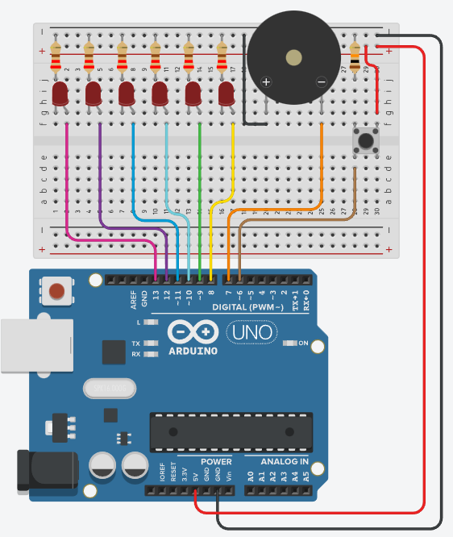
Figure 5 shows the circuit used in the other 2 versions of code

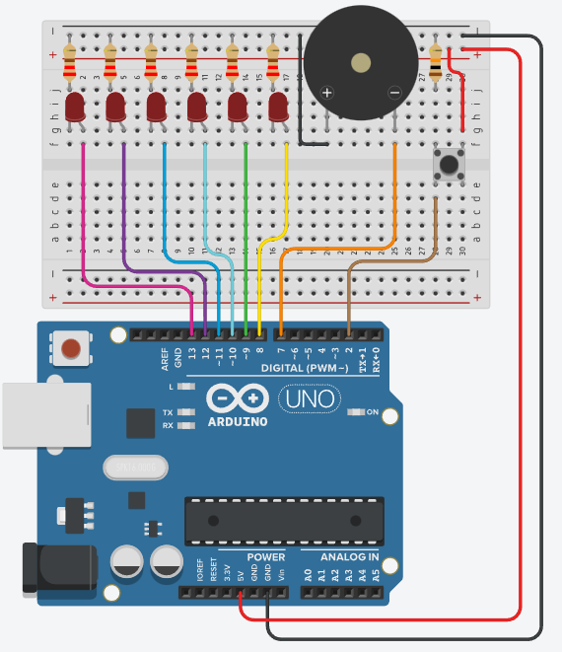
Figure 6 illustrates the circuit used with the interrupt function which only support pins 2 and 1.
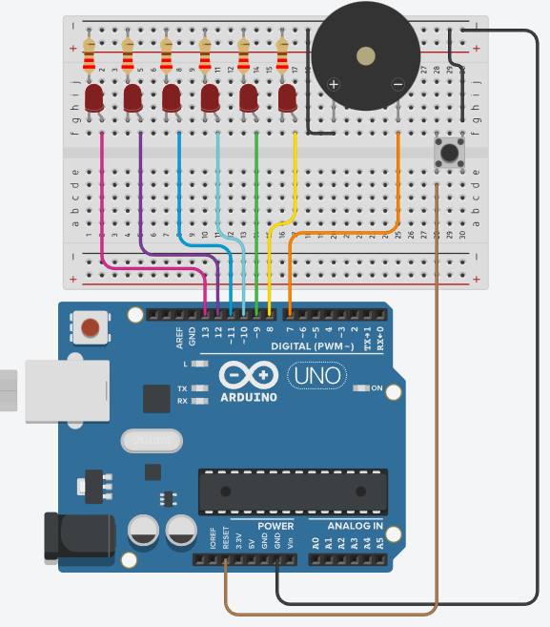
Figure 7 shows the circuit for the “Reset Pin” code

